Mainpage 🎙️ Podcast 🎙️ Listen Instead 🛍️ Support the Show 🏠 Communities

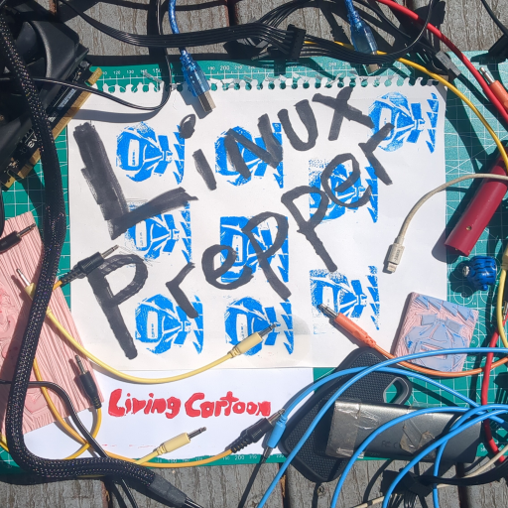
Welcome to the home of Linux Prepper Podcast!
This wiki is the ongoing attempt at:
- Migrating a live, existing system over to livingcartoon.org
- Building out resources for listeners and the curious!
- Upcoming Events
Unsure if a wiki is for you? Check out the forum!

